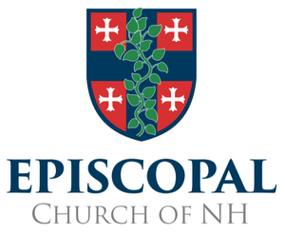
COMMISSION on MINISTRY CONFERENCE
Barbara C. Harris Center
108 Wally Stone Lane, Greenfield, NH

Beginning at 10:00 am on Friday, March 27, 2015 and ending at 2:30 pm on Saturday, March 28, 2015
Please RSVP and indicate the following:
Name: _______________________________________________________________________
Email address: ________________________________________________________________
I prefer the following (choose one option):
____ I would like to stay overnight in a shared room:
____ I would like to share a room with __________________________________ OR
____ Feel free to place with me a roommate
____ I would like to stay overnight in a single room ($50 donation please, make check out to Episcopal Diocese for NH and write “COM retreat” in the memo line)
___ I will commute back and forth to the meetings on Friday and Saturday and will not stay overnight:
But please count me in for the following meals:
___ Lunch on Friday
___ Dinner on Friday
___ Breakfast on Saturday
___ Lunch on Saturday
___ I am sorry, but I can’t make it!

I have the following special needs or dietary restrictions: ______________________________________________

