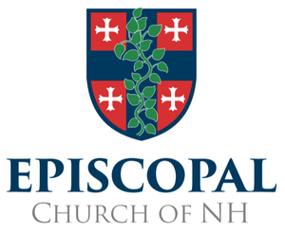
Declaration of Intention

In the Name of the Father, and of the Son, and of the Holy Spirit. Amen.

We,

And

understand the teaching of the Church that God’s purpose for our marriage is for our mutual joy, for the help and comfort we will give to each other in prosperity and adversity, and, when it is God’s will, for the gift and heritage of children and their nurture in the knowledge and love of God. We also understand that our marriage is to be unconditional, exclusive, faithful and lifelong; and we engage to make the utmost effort to accept these gifts and fulfill these duties, with the help of God and the support of our community.

__________________________ _________________________
Signature Signature

Dated A.D.

