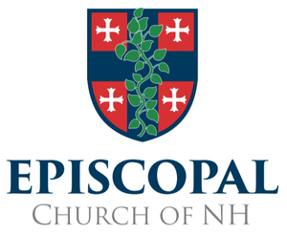

We often forget that the Church has an amplifying, magnifying, and intensifying effect on word, gesture, and touch. Human interactions that take place in a church building or in the context of a church activity have an increased capacity to heal and inspire, or to harm and confuse. We can leave it to the religioius anthropologist and sociologist to explalin, but the more experience we have in the spiritual community, the more we can attest to the power that accrues to verbal and physical exchanges that happen in Church. A compliment or a criticism spoken during a worship service, coffee hour, Sunday School, Youth Group or Vestry carries with it a more powerful energy because it is spoken in the presumed Presence of the Holy One.
It is within this understanding and sacred sensitivity that I invite you to participate in our Diocesan Safe Church Training. The persons who show up in the Christian community do not arrive by accident. Holy Scripture tells us that they are led to us by the Spirit, and we are called by the same Spirit to receive them as beholders of God’s image, God’s very presence (see Genesis 18, Matthew 25, Hebrews 13). Safe Church Training, therefore, is not merely an exercise required by the institutional bureaucracy, mandated by our insurance providers. Much more than that, I urge you to enter into these sessions with a contemplative attitute of openness by which we learn again how to be holy in our interactions with each other and with those, both young and old, who come seeking and expecting holiness in our congregations.
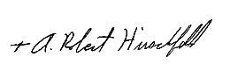
The Rt. Rev. A. Robert Hirschfeld
Bishop

