REQUIRED MODULES FOR INITIAL UNIVERSAL TRAINING

Meet Sam

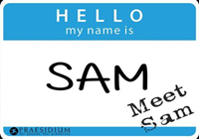

Sam molests children and in this module he tells you how he gets away with it. You learn the types of molesters and the methods they use to manipulate their coworkers, parents, and children-all to meet their own needs. You also learn how to spot interactions between adults and children that may indicate danger.
It Happened to Me

Temper outbursts. Failing grades. Depression. Suicide. These are just a few of the effects of sexual abuse. In this module, you hear children and adults describe the devastating effects abuse had on their lives. You learn about the prevalence of abuse and specific characteristics that may put some children at higher risk of abuse.

Keeping Your Church Safe

God has entrusted you with something precious to Him - His children. Designed with the special needs of churches in mind, in Keeping Your Church Safe you will learn five specific ways your actions can keep children safe, the importance of keeping a watchful eye, what to do in the case of suspicious situations, and how to respond to inappropriate behavior. This course is a vital asset to your church ministries as it includes information about how molesters operate and provides helpful guidelines for screening applicants and keeping children safe throughout your church.

Safeguarding God's People: Preventing Sexual Exploitation in Communities of Faith - for Congregations

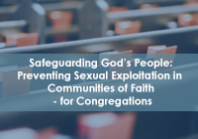
*This course contains many video clips. A high speed Internet connection is required. You will experience long delays without high speed Internet access.
In this course you will learn:
- The definition of, and facts about, sexual exploitation
- The effects of sexual exploitation
- Facts about power in pastoral relationships
- How sexual exploitation happens
- How to prevent sexual exploitation
- How to respond to sexual exploitation

Your Policies

You must know your organization policies relevant to the prevention of abuse. To complete the module, you must indicate on-line that you have read, understood, and agree to comply with the policies.

REQUIRED MODULE FOR RENEWING TRAINING

Abuse Prevention Refresher

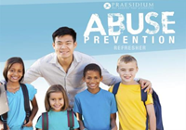
Welcome back! Your prior training and on-the-job experience has given you a great foundation for preventing child sexual abuse. In Advanced Abuse Prevention you'll build on this knowledge and learn new information about:
1. How sexual abuse occurs in organizations.
2. How to use red flags to keep kids safe.
3. How to prevent false allegations of abuse.
4. How to prevent sexual activity between children.
5. How to apply what you know!

Recognizing Abuse and Exploitation in Elder Serving Programs

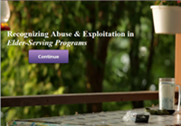
As an employee or volunteer with an elder-serving program, you provide a valuable service to those in your care.
This course teaches you how to recognize and prevent mistreatment of elderly people. You will learn about the types of abuse, neglect, and exploitation, including how they occur and how to report them. You will also learn tips for providing quality care to the elderly while protecting yourself from false allegations of abuse.

RECOMMENDED FOR PEOPLE WORKING WITH YOUTH

Social Media Safety
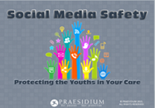
Social media safety is a relevant topic for everyone who works with young people. In a short period of time, new technologies have revolutionized the way we all communicate. This course introduces guidelines for protecting the youths in your care when using social media and electronic communication. You will learn how to:
- Identify the risks of using social media and other forms of electronic communication
- Follow policies and best practices governing the use of social media and electronic communication
- Educate youths and parents about online safety
- Respond appropriately to improper and illegal use of social media/electronic communication

